NMS installation guide

1. Disable firewall
2. Run server manager to add roles
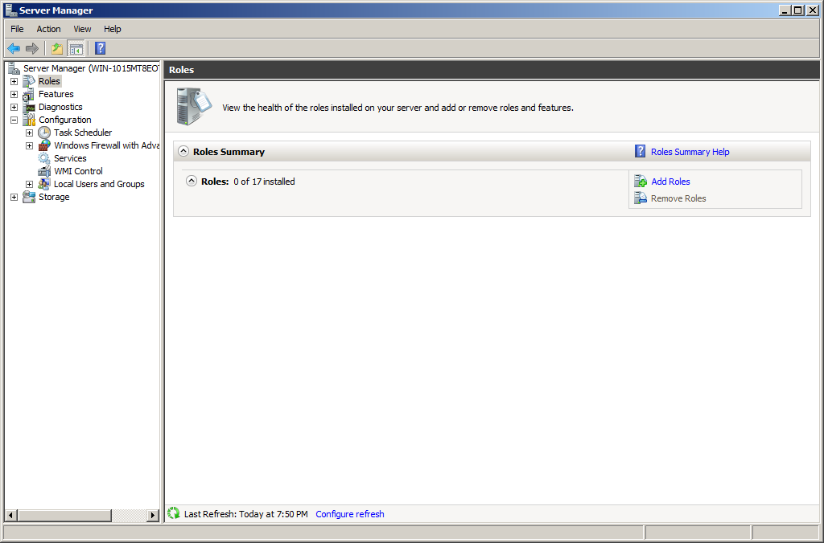
Confirm there server：
- Application server
- Web server

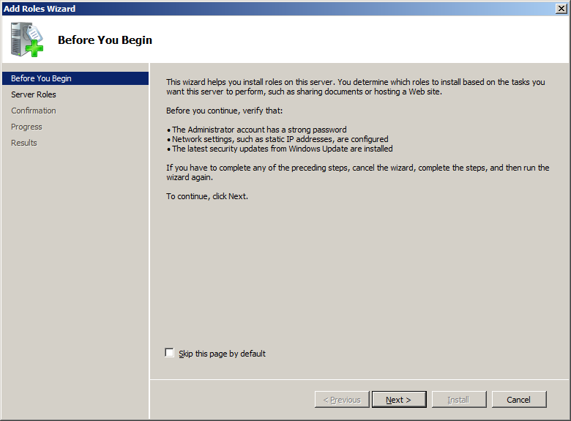
Add application server
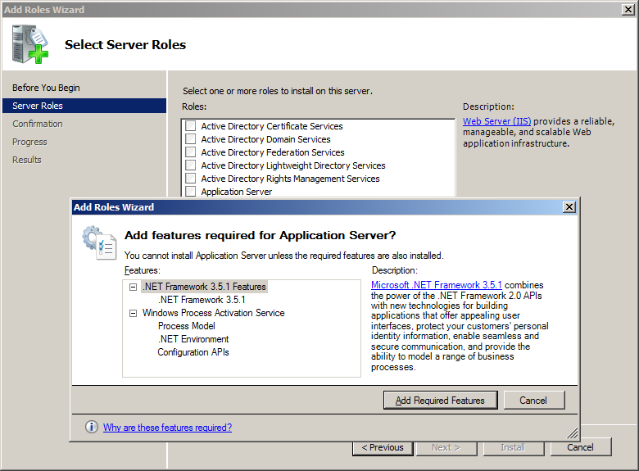

Add web server
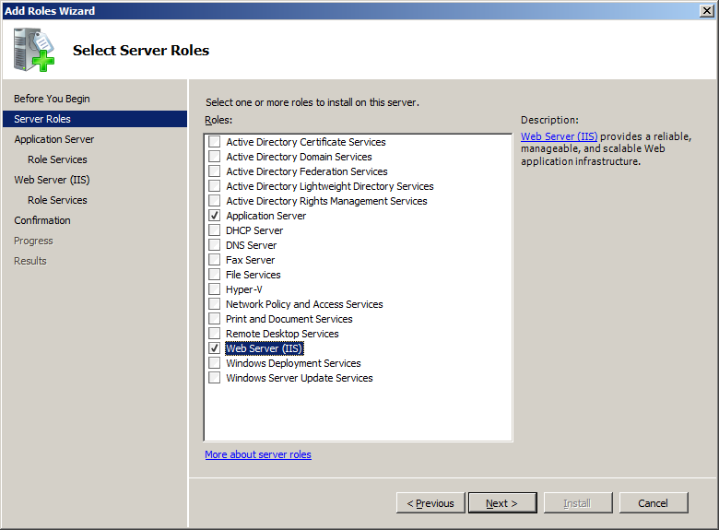
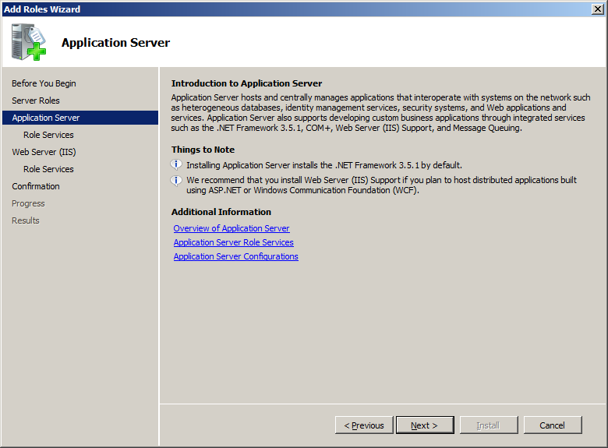

Choose web server(IIS) support
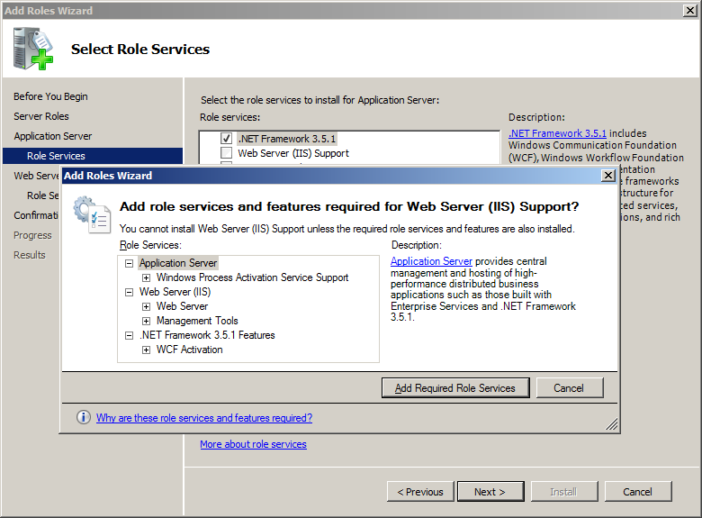
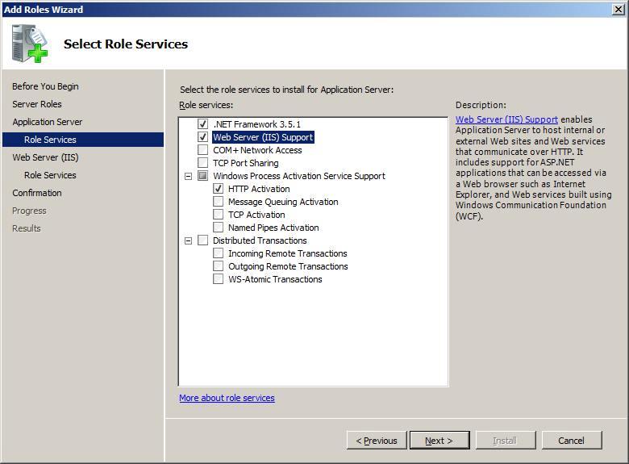
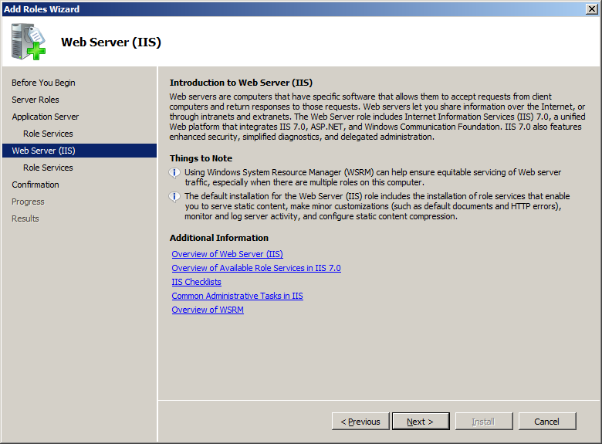
Choose Role services
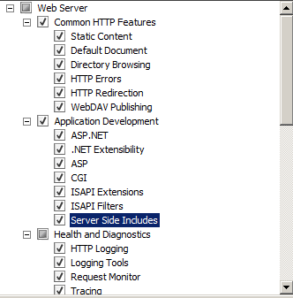
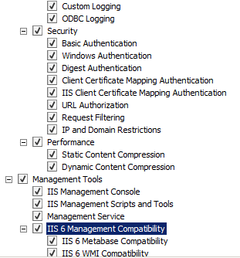
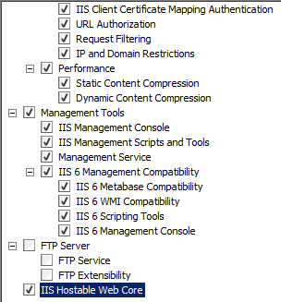
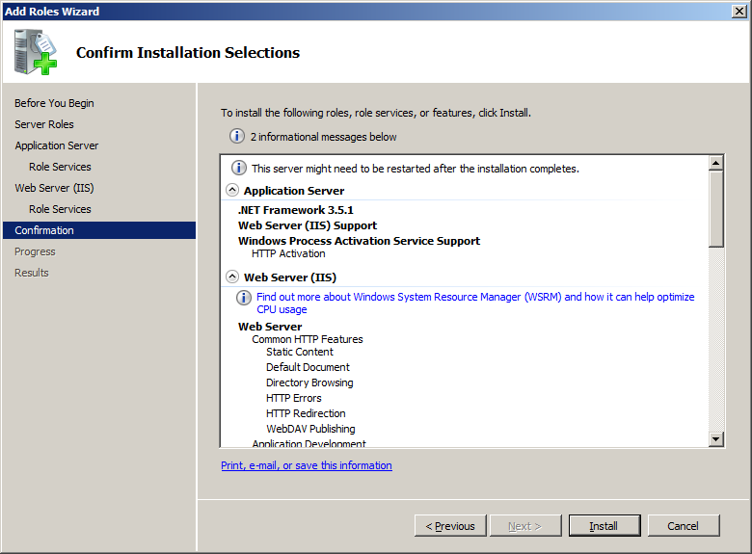
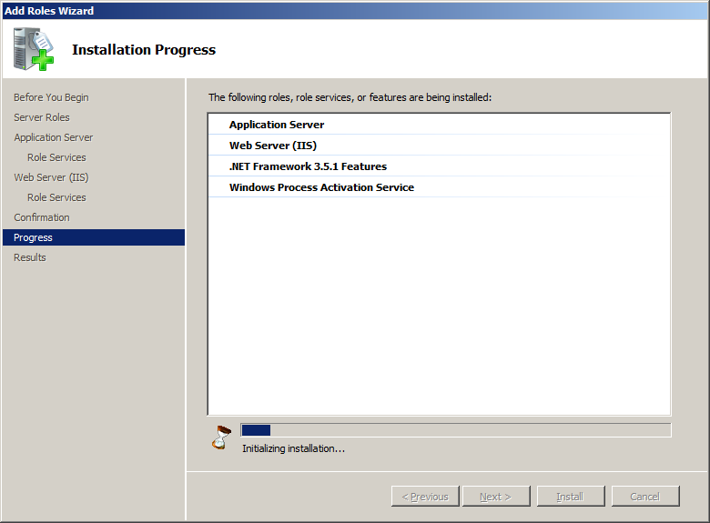
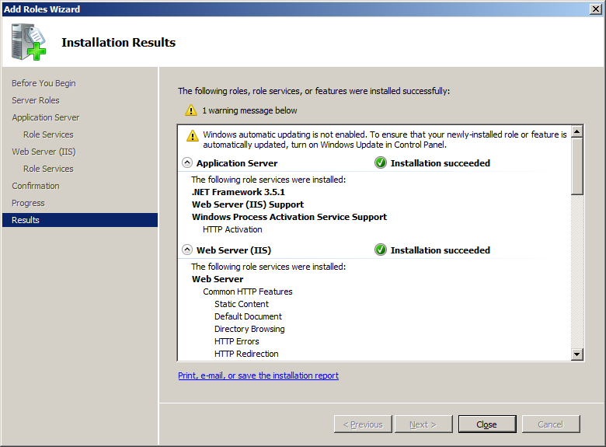

- Install NMS component
Run setup
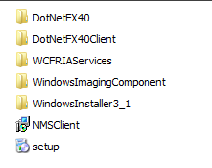

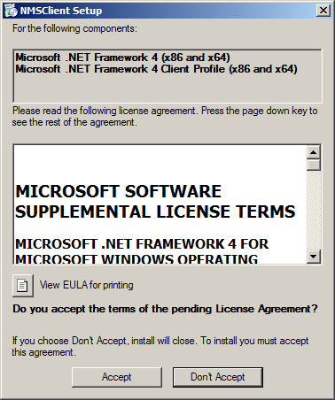
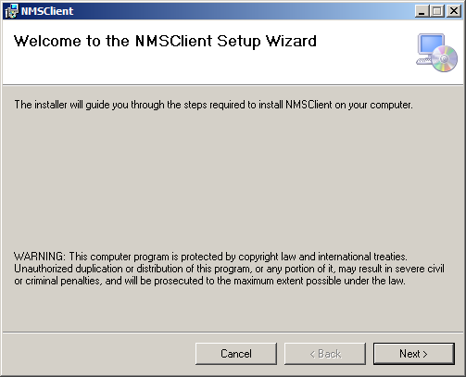
Choose ASP.NET v4.0
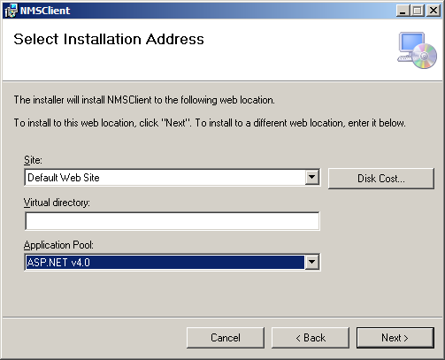
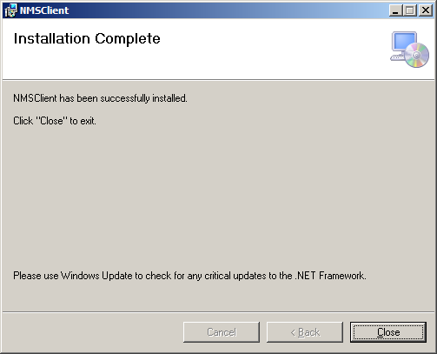

- install Oracle 10G XE .
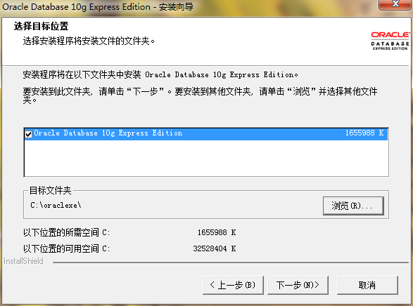
Input : ktcatv

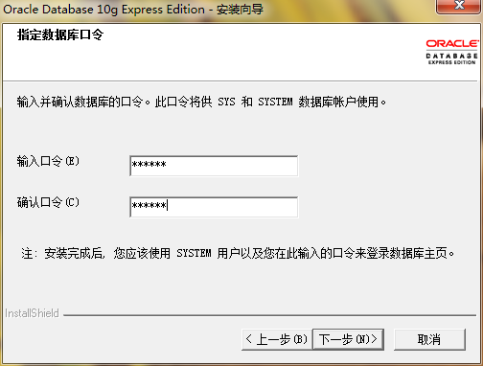
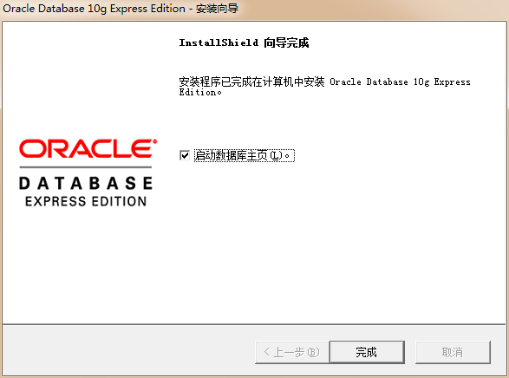

Username: sys
Password: ktcatv
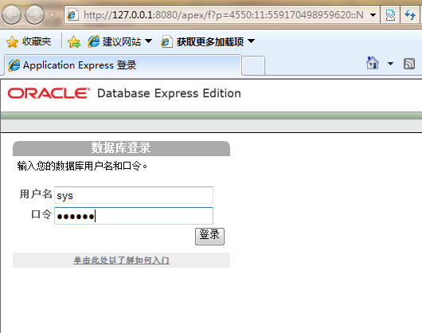
Create database ：

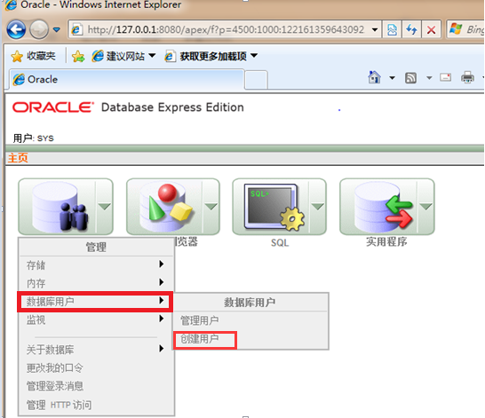

Create User name: nms password: ktcatv
Choose DBA
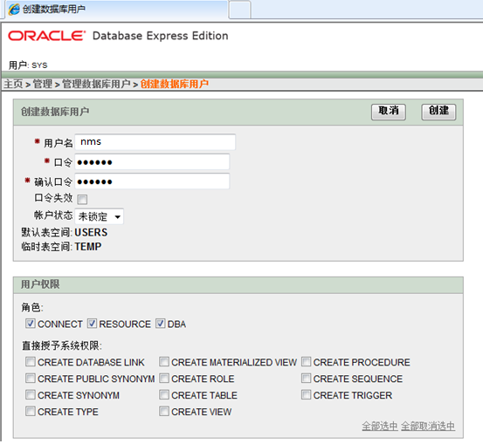

5.install ODTwithODAC
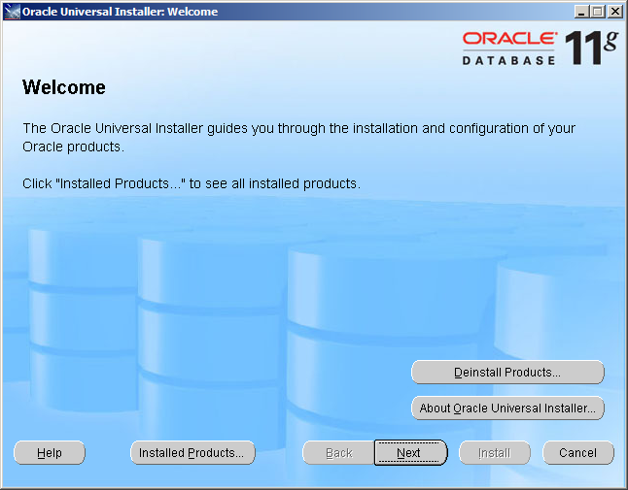
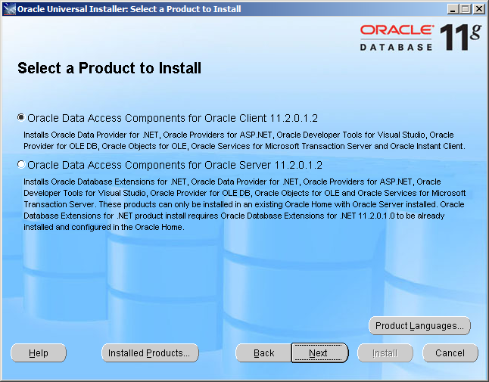
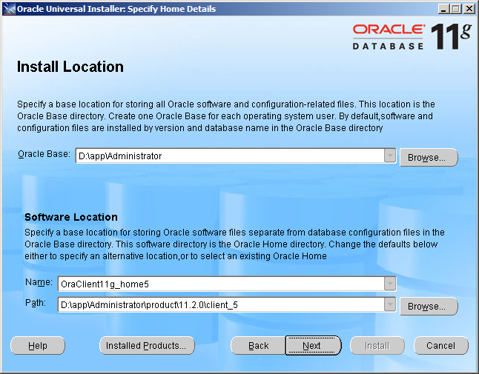
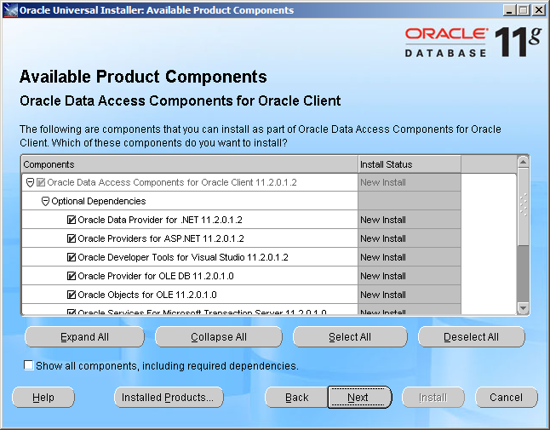
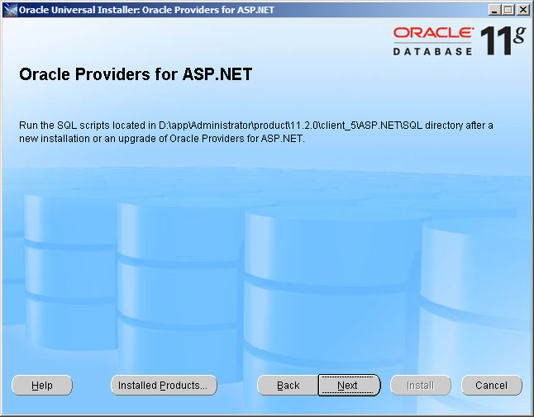
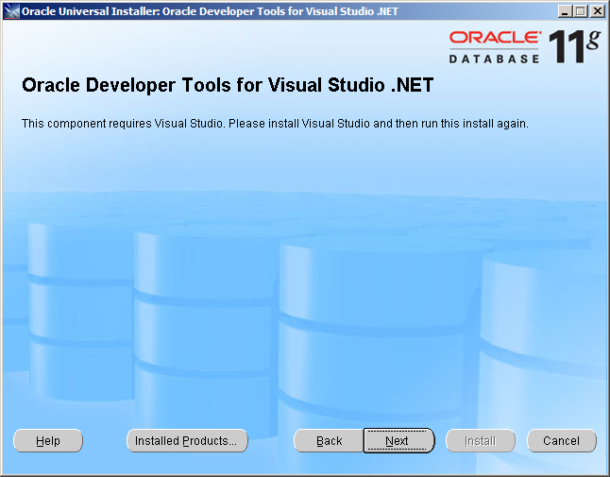
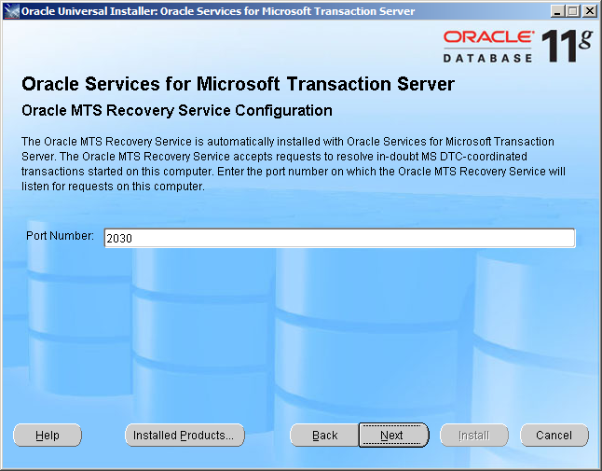
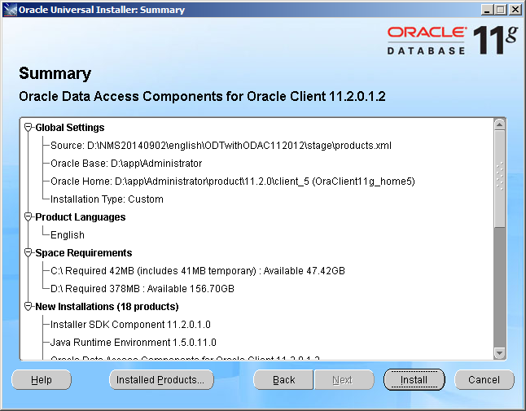
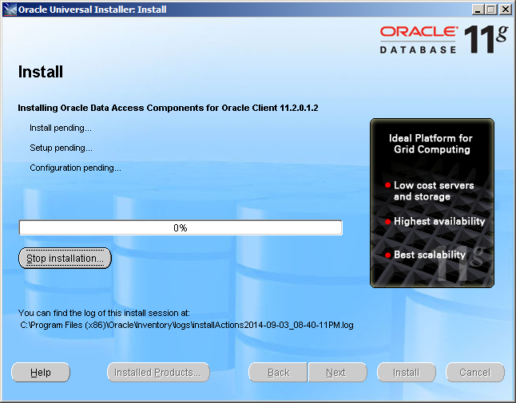
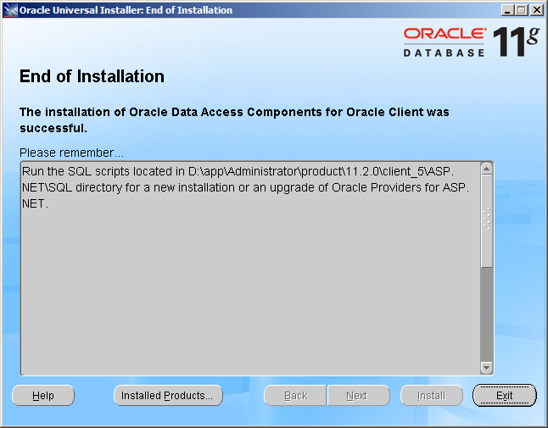

6.Run SQL Plus

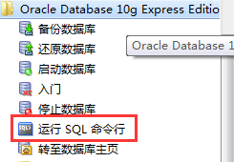

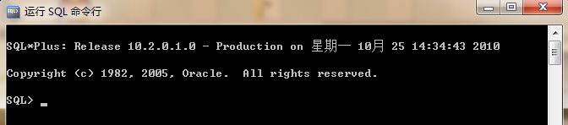

Preform these commands：

conn nms/ktcatv@127.0.0.1
alter system set sessions=555 scope=spfile;
alter system set processes=500 scope=spfile;

Like this ：
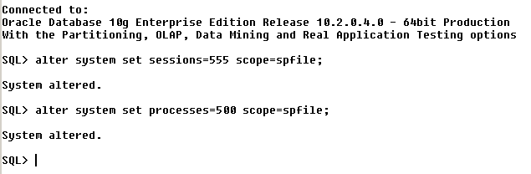

Import database：
Put nmsdb.dmp in c:\，run cmd command in windows and these command：
Imp nms/ktcatv@127.0.0.1/xe file=c:\nmsdb.dmp full=y

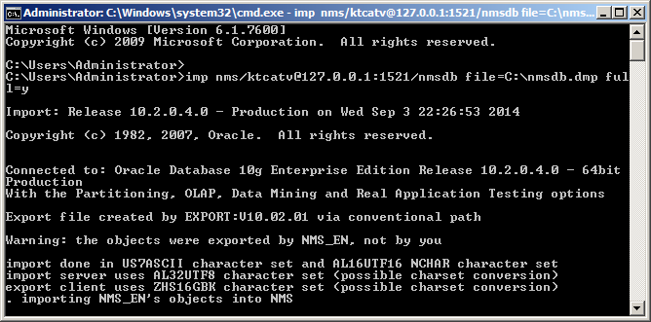
7.configure server
Choose ASP.NET V4.0
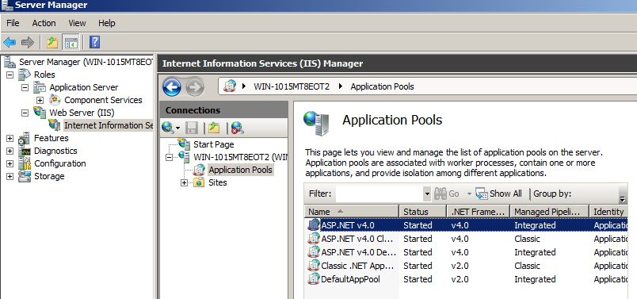
Right-click :advanced settings

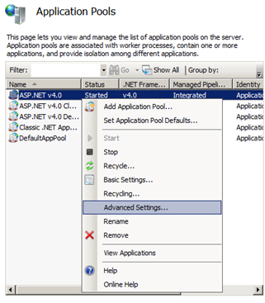
Modify enable 32-bit applications true
Maximum worker processes 2
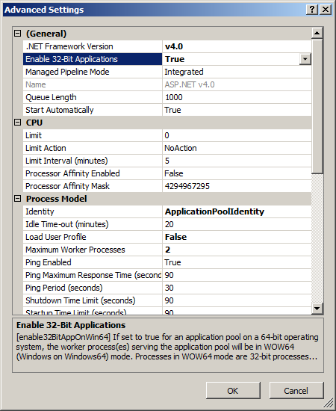
click explore

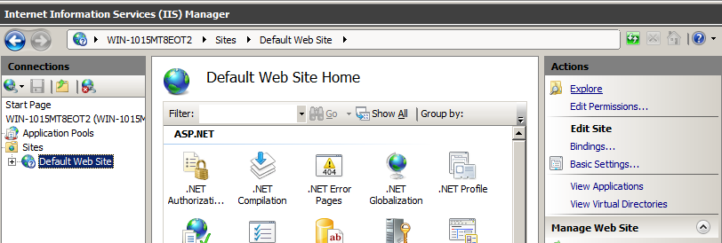

Copy all files in NMS_Client folder
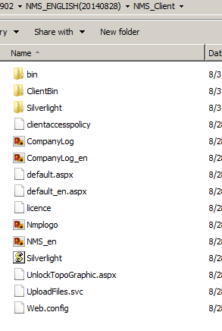
Paste all files to the folder opened with ‘ explore’ menu，normally
C:\inetpub\wwwroot

Use notepad software to open
Find this part below and modify to user id=nms password=ktcatv data source=127.0.0.1/xe

Find this part below and modify to c:\inetpub\wwwroot\clinetBin

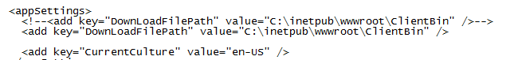

Open in
Find this part below and modify to

<add name="NMPConnection" connectionString="User Id=nms;Password=ktcatv;Data Source=127.0.0.1/xe" providerName="Oracle.DataAccess.Client"/>

Modify RemotingIP to the IP which server use, don’t use 127.0.0.1

add key="RemotingIP" value="192.168.1.199"

Check this red square .if it display 80 make sure value=0 ;if not 80 value=1
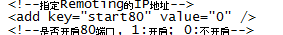
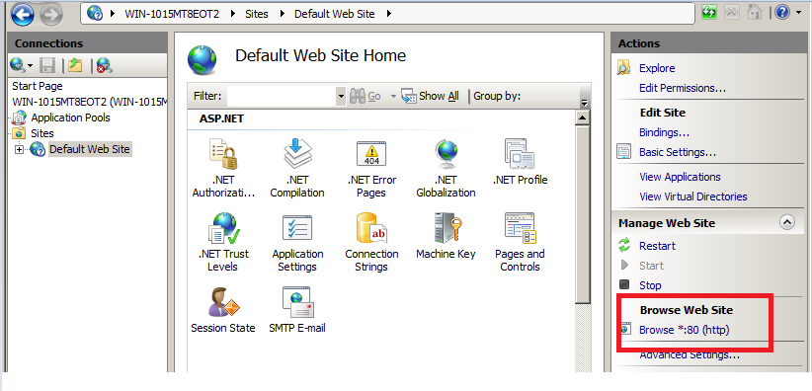

Save NMPServerConfig and COPY to NMSListenTrap

Activate the Local Area Connection and Set IP address as :192.168.1.199 255.255.0.0
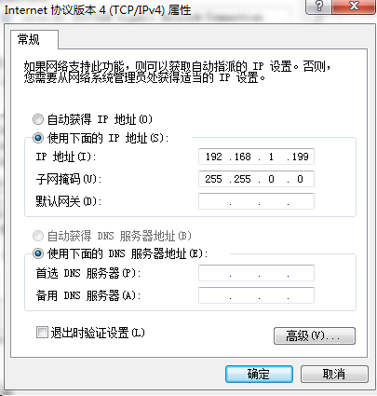

Use Internet explorer and open http://localhost/

Install sliverlight
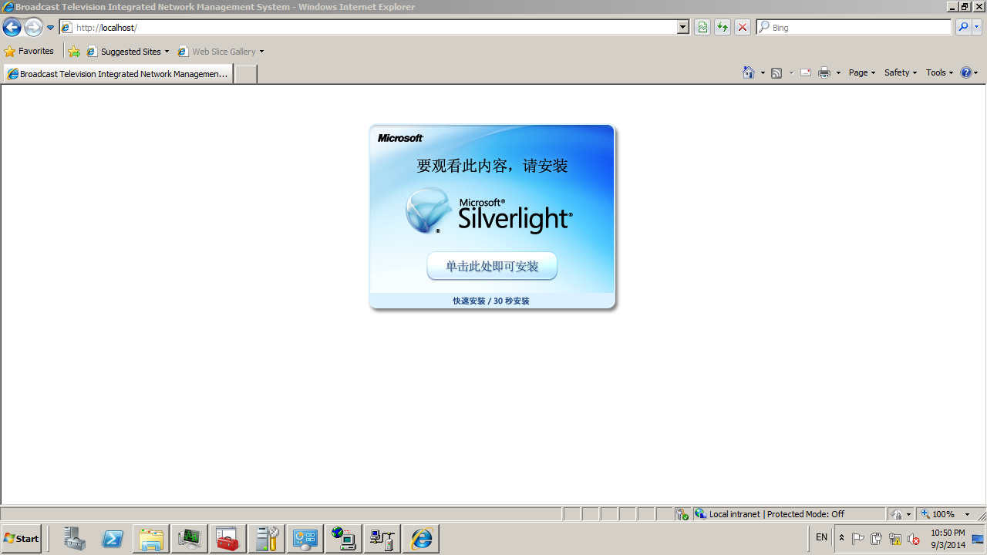
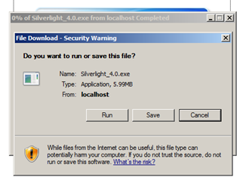
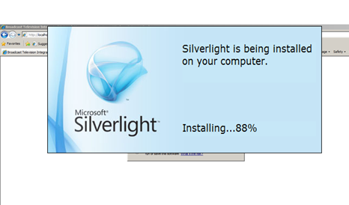
Do not choose enable microsoft update
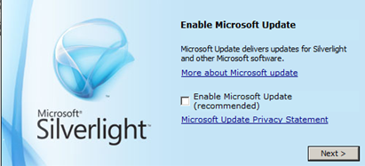

Enter NMS system user name is admin password none

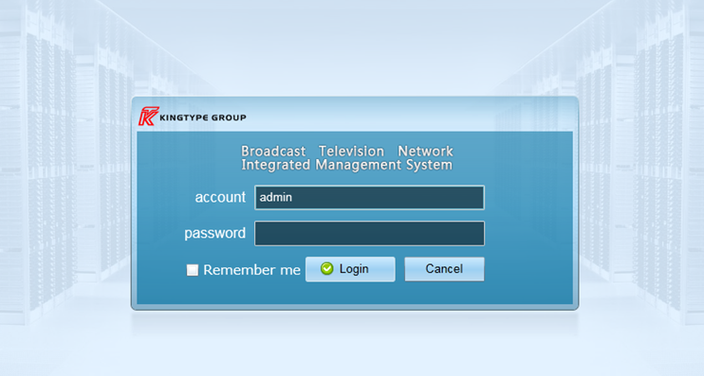
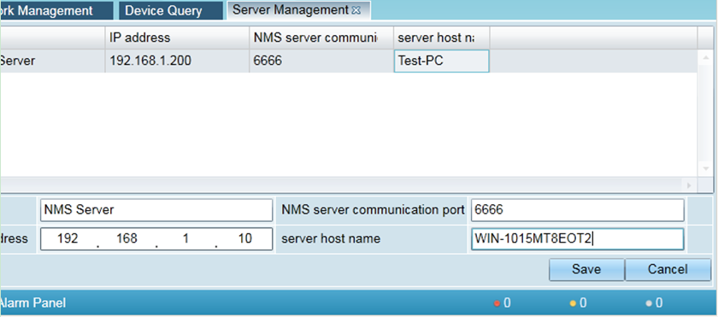
Modify this ip address to server’s IP
Modify server host name same with computer name
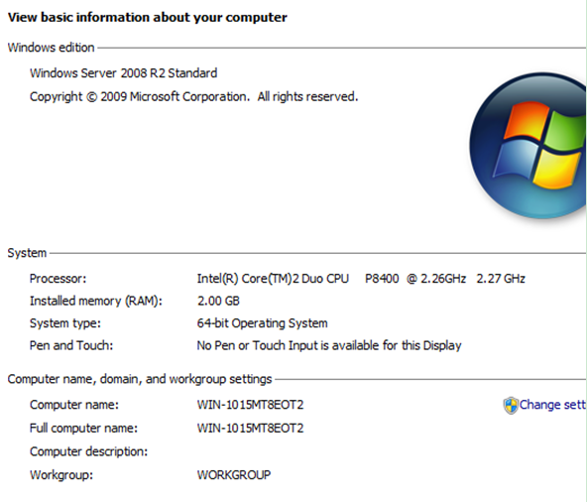
Run these software as administrator
ListenTrap 和ConsoleApp

All finish.

